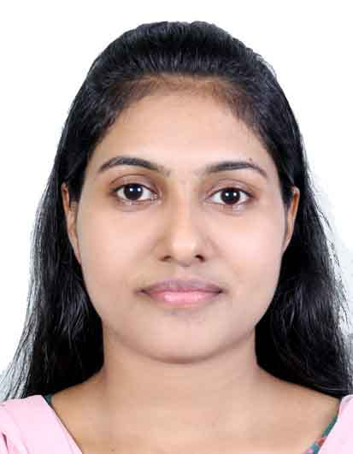
RINCY RAJU

Kerala, India

+91 95 2677 4771

rincyrinsa1991@gmail.com

SUMMARY
Experienced Office Management and Administration Professional with 07 years of experience optimizing productivity, efficiency and service quality across various environments. Highly dependable, ethical and reliable support specialist and leader that blends advanced organizational, technical and business acumen. Works effectively with cross-functional teams in ensuring operational and service excellence.

EDUCATION
2014 - 2015 | Master of Business Administration,  University of Madras, India
2013- 2014 | Diploma in Computerised Financial Accounting,  Nehru Centre For Education & Technology, India

2010- 2013 | Bachelor Of Commerce  Mahatma Gandhi University- India

EXPERIENCE

MARUTI SUZUKI POPULAR VEHICLES & SERVICES LTD- INDIA
Position: Customer Care Executive (2016 – Present)
Main duties performed:

- Conferred with sales teams and team leaders to communicate targets, boost revenue and improve promotional strategies.
- Exceeded team goals and collaborated with staff members to implement customer service initiatives.
- Achieved and consistently exceeded revenue quota through product and service promotion during routine calls.
- Responded to customer requests for products, services and company information.
- Analyze and Make Decisions Based on Customer Care Data
- Handle Escalated Customer Issues

SKILLS

- Good Communication skills
- Faithful and honest
- Efficiency in leading a team
- Ability to work with people and lead them
- Ability to unveil and use the potential of the team members

REFFERENCE
- Sinchu John - Maruti Suzuki Popular Vehicles & Services Ltd- India

PERSONAL INFORMATION

Date of Birth : 2nd November 1991
Nationality : Indian
Passport No : K5693426
Place of Issue : Trivandrum
Date of issue : 03/08/2012
Date of Expiry : 02/08/2022
Language known : English, Malayalam

DECLARATION

I hereby solemnly declare that the above furnished particulars are true to the best of my knowledge and belief. On the event of my selection to do this job, I shall do my best to the maximum benefit of the company.

Rincy Raju

